**Test Log:**

**Unite test**

|  |  |  |  |  |
| --- | --- | --- | --- | --- |
| Test ID | Name of test | Description | Outcome | Result |
| 1 | Unit test |  |  |  |

**2. Integration Test**

**Integration Test 1**

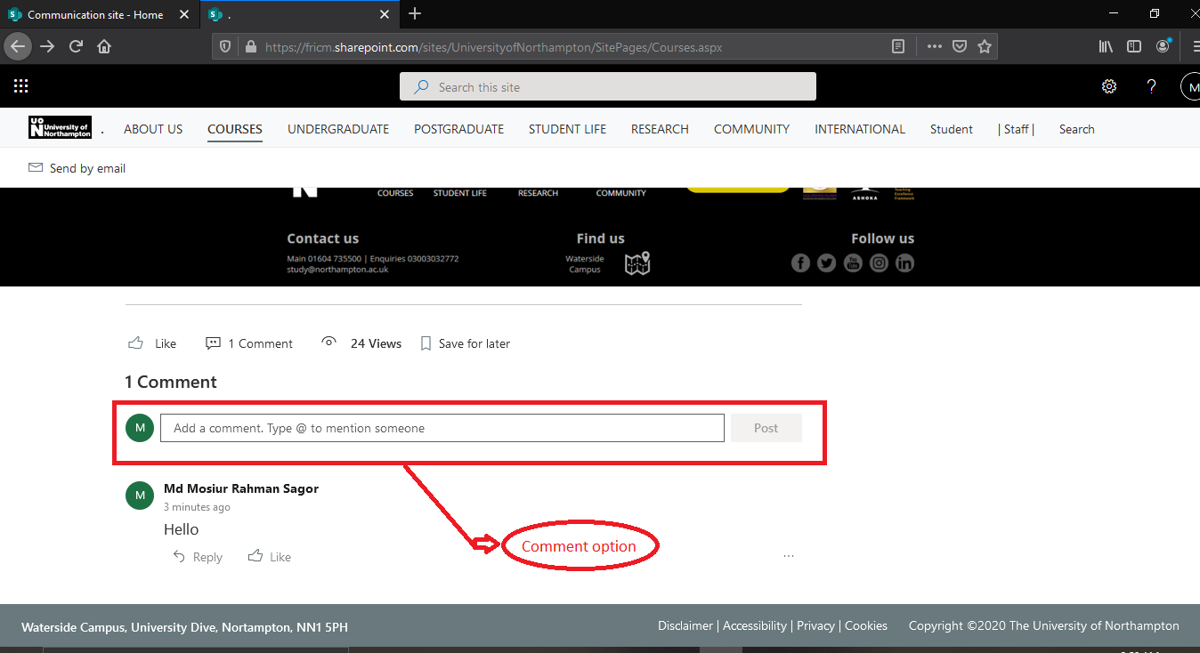

**Figure:**  In comment option post comments.

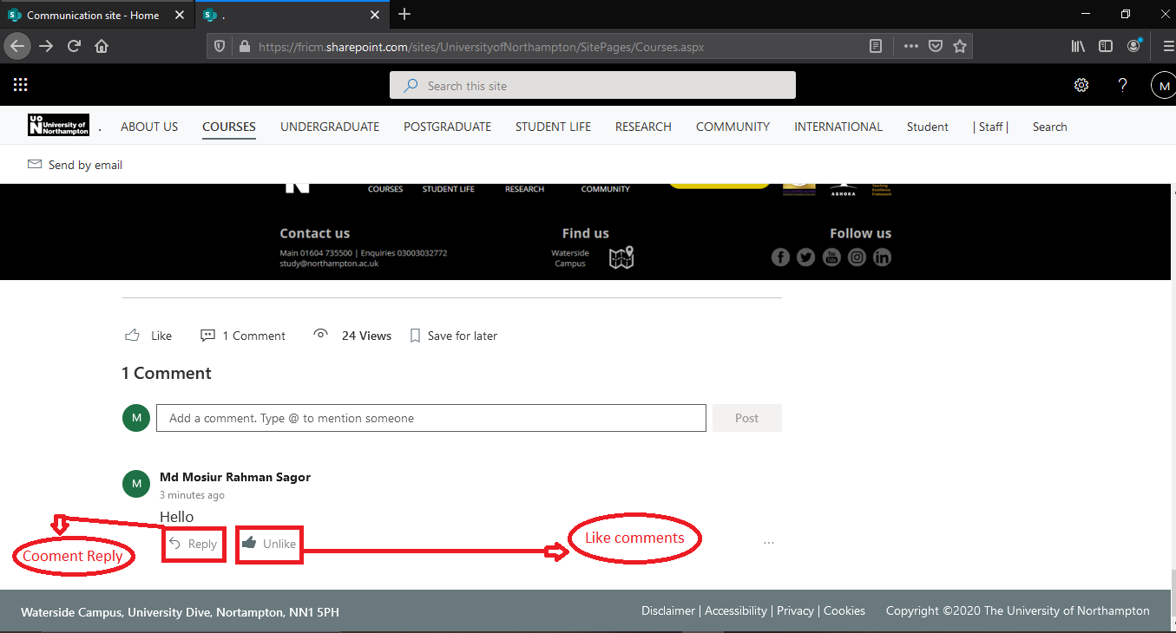

**Figure:**  comment can be like and reply comment.

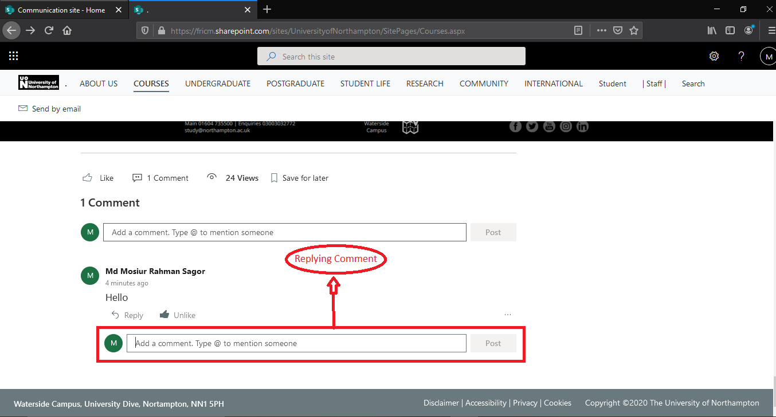

**Figure:**  Comment Reply in reply button.

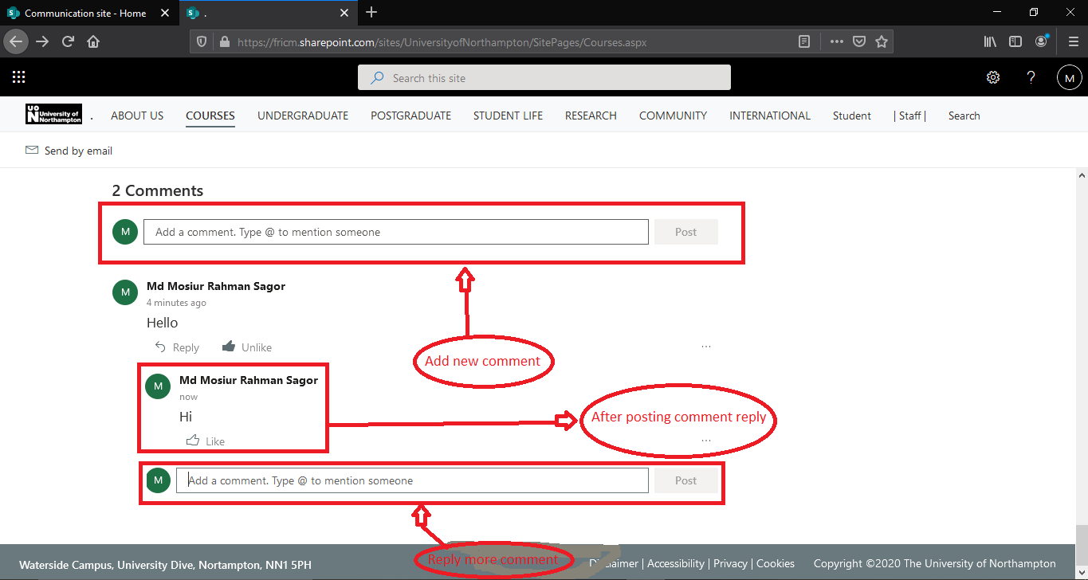

**Figure:**  After reply comment and can add new comment.

**Integration Test 2**

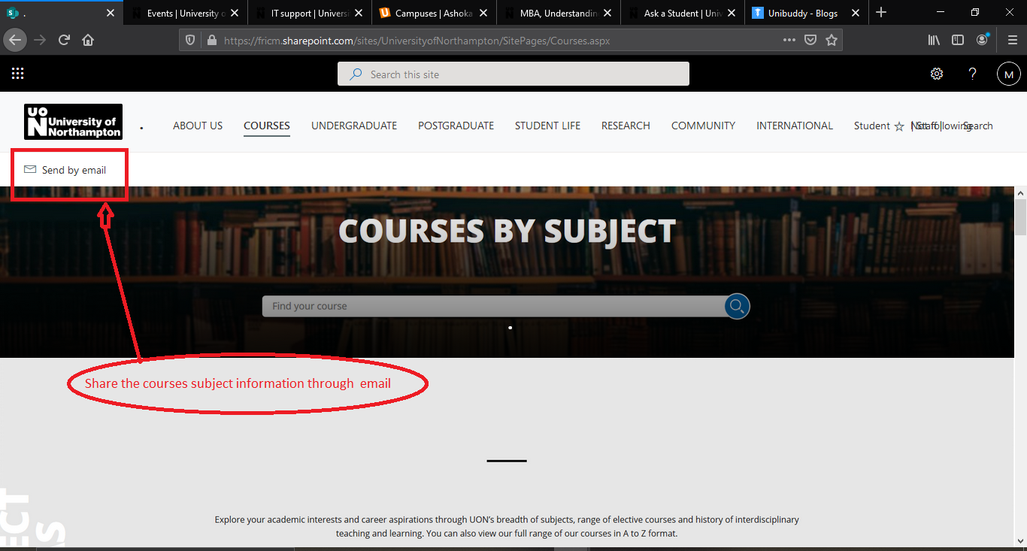

**Figure:**  Click the send by email for send email.

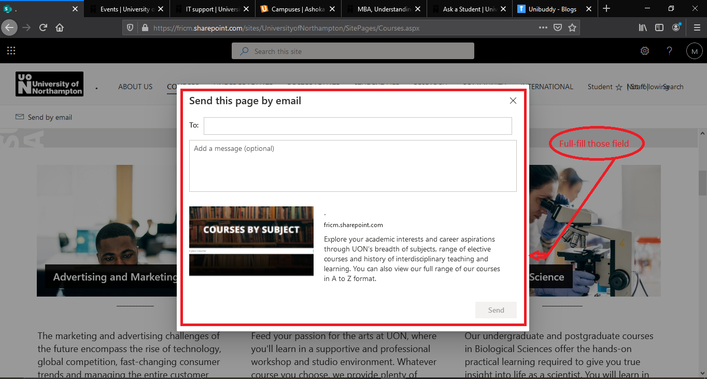

**Figure:**  full-full the entire field.

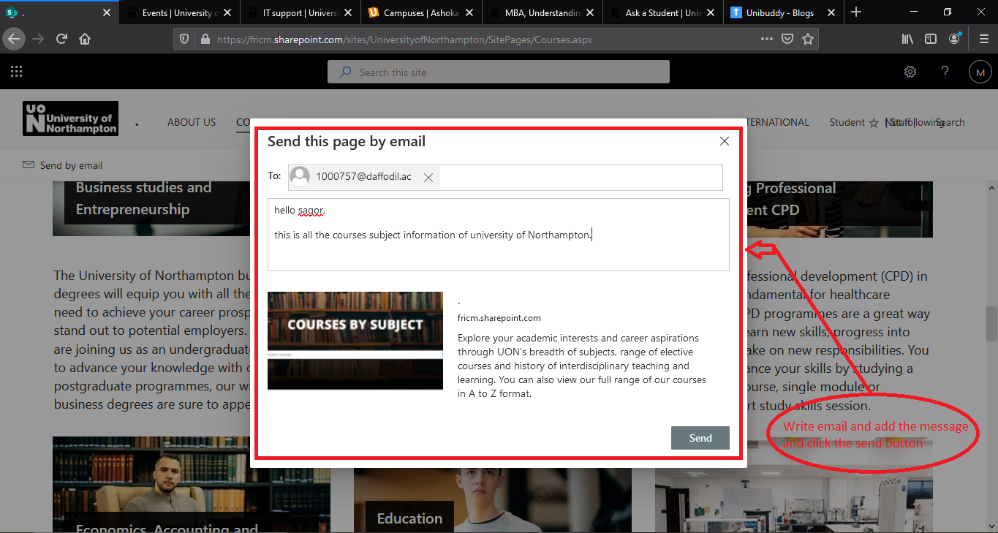

**Figure:**  After full-full the entire fields then click the send button.

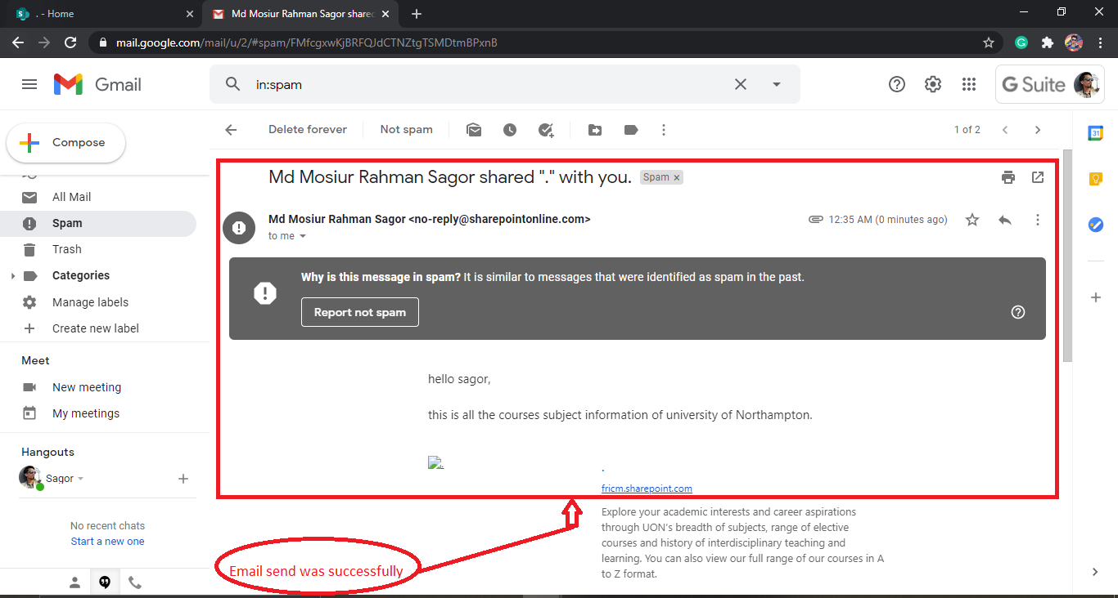

**Figure:**  Email sends successfully.

|  |  |  |  |  |
| --- | --- | --- | --- | --- |
| Test ID | Name of test | Description | Outcome | Result |
| 2 | Integration test | How the Integration has work in the system | The response of the Integration was good. | PASSED |

**3. Functional Test**

**Functional Test 1**

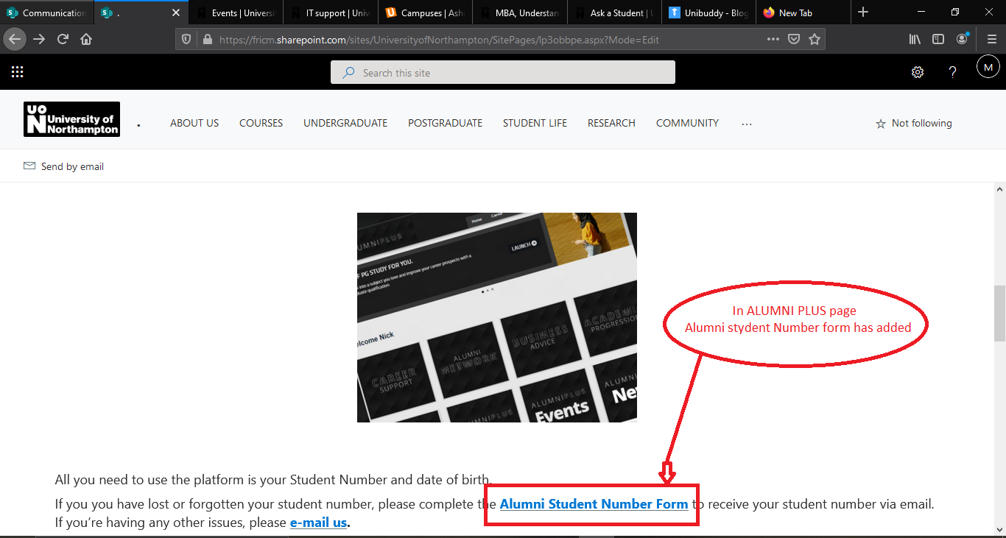

**Figure:**  Click the Alumni student number form

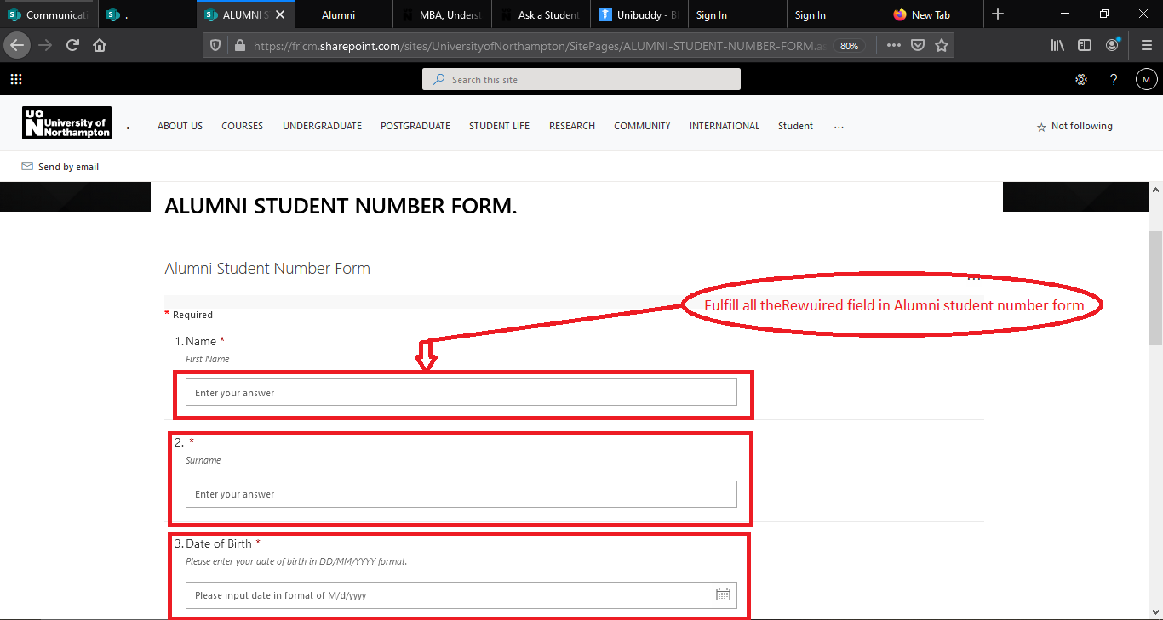

**Figure:**  Fulfill all the Requirements form.

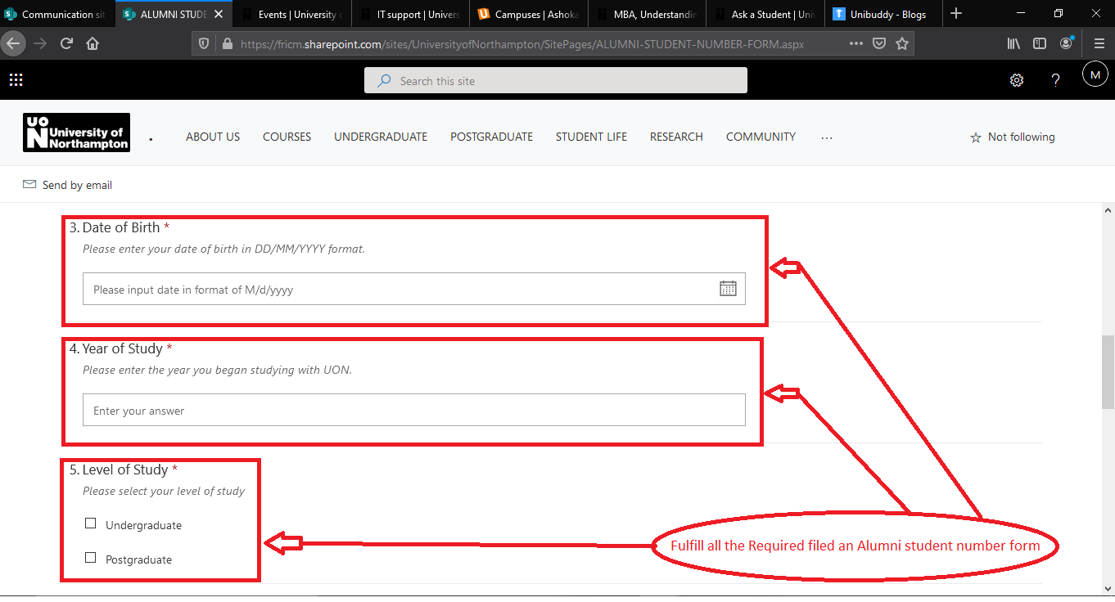

**Figure:**  Fulfill all the Requirements form.

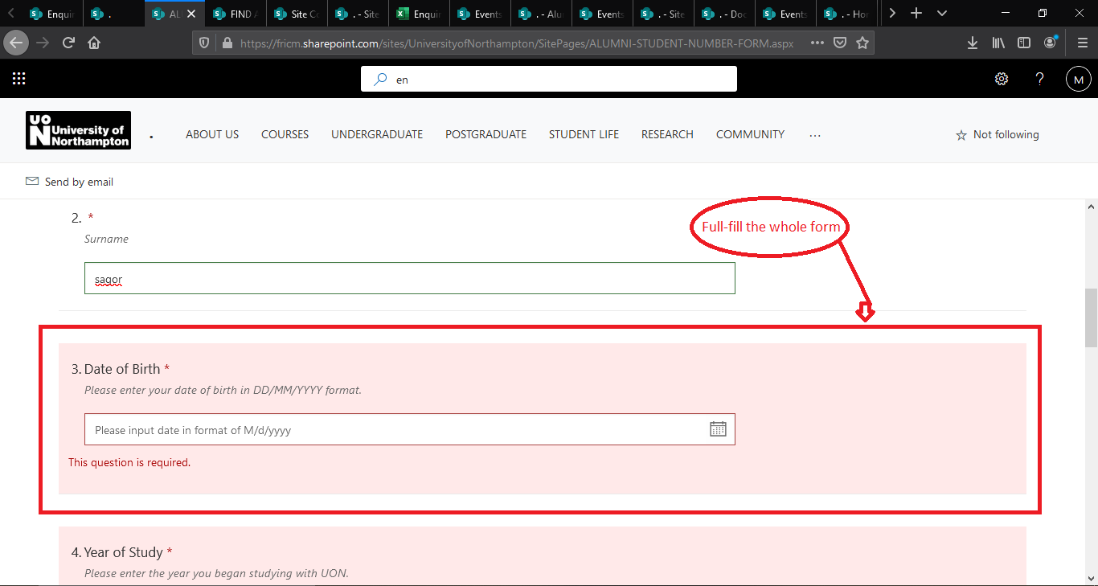

**Figure:**  Without fulfill the whole form .

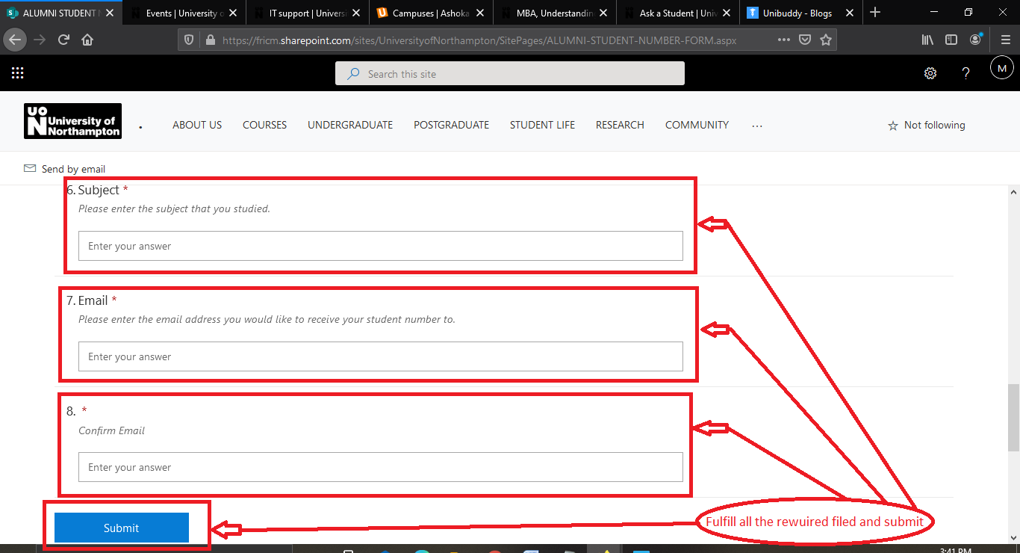

**Figure:**  Fulfill all the Requirements form and Click the submit button.

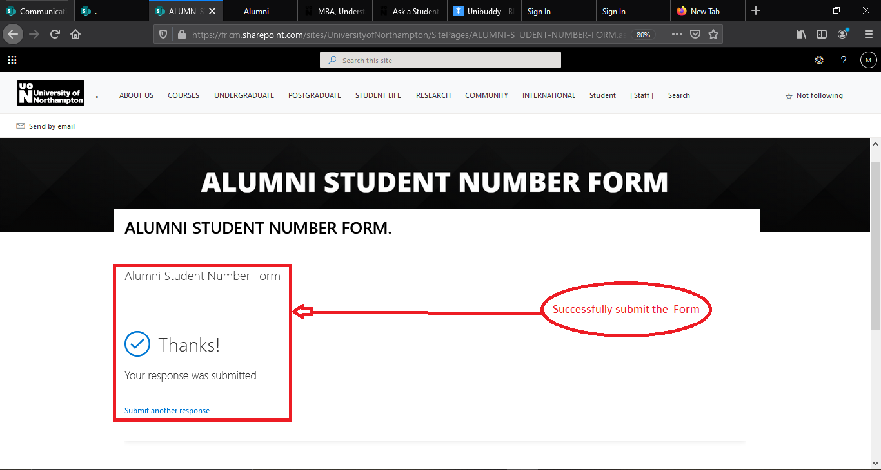

**Figure:**  Successfully submit the form has been show.

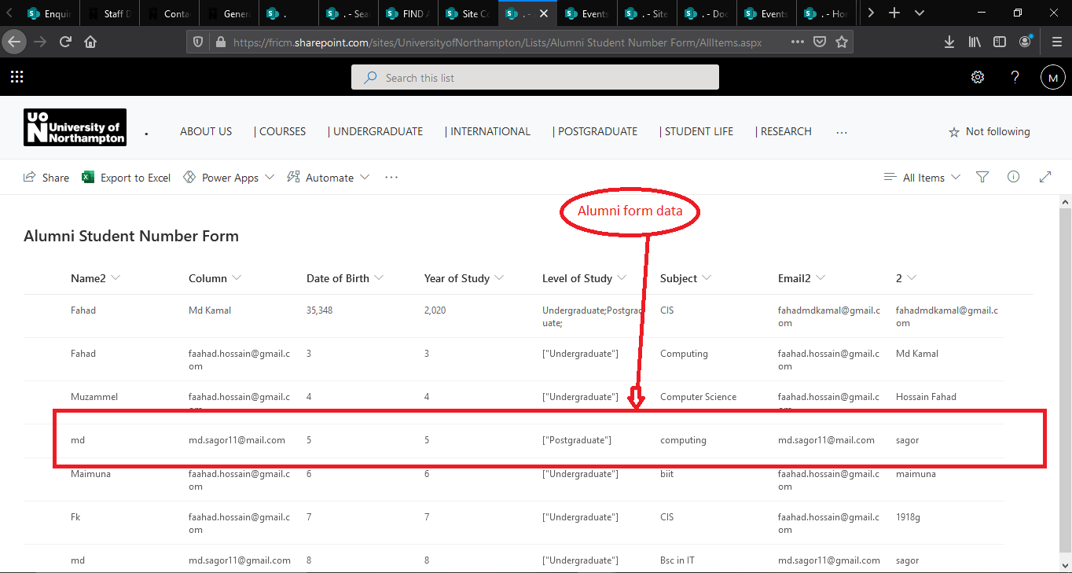

**Figure:**  The alumni student number form data has been save.

**Functional Test 2**

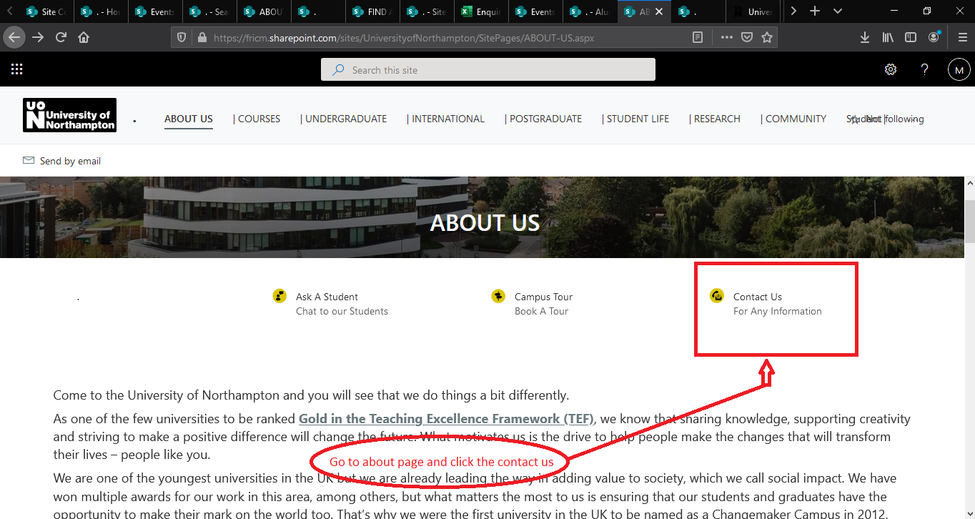

**Figure:**  Go to about us page and click the contact us.

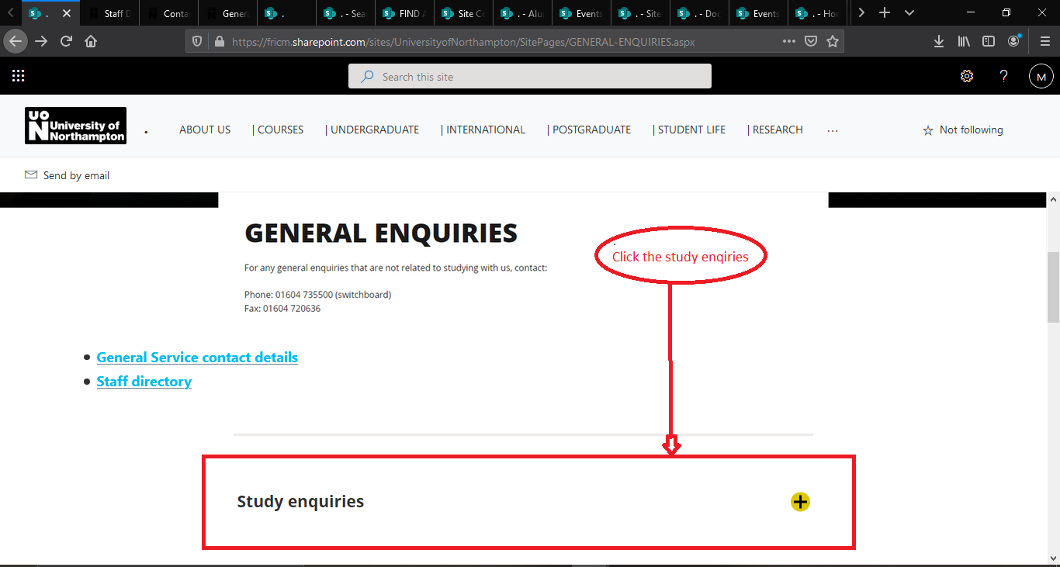

**Figure:**  Now click the study enquiries.

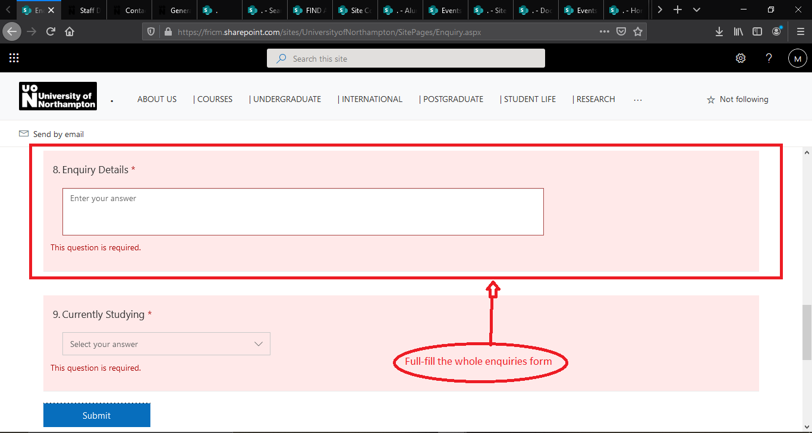

**Figure:**  Fulfill all the Requirements form and Click the submit button.

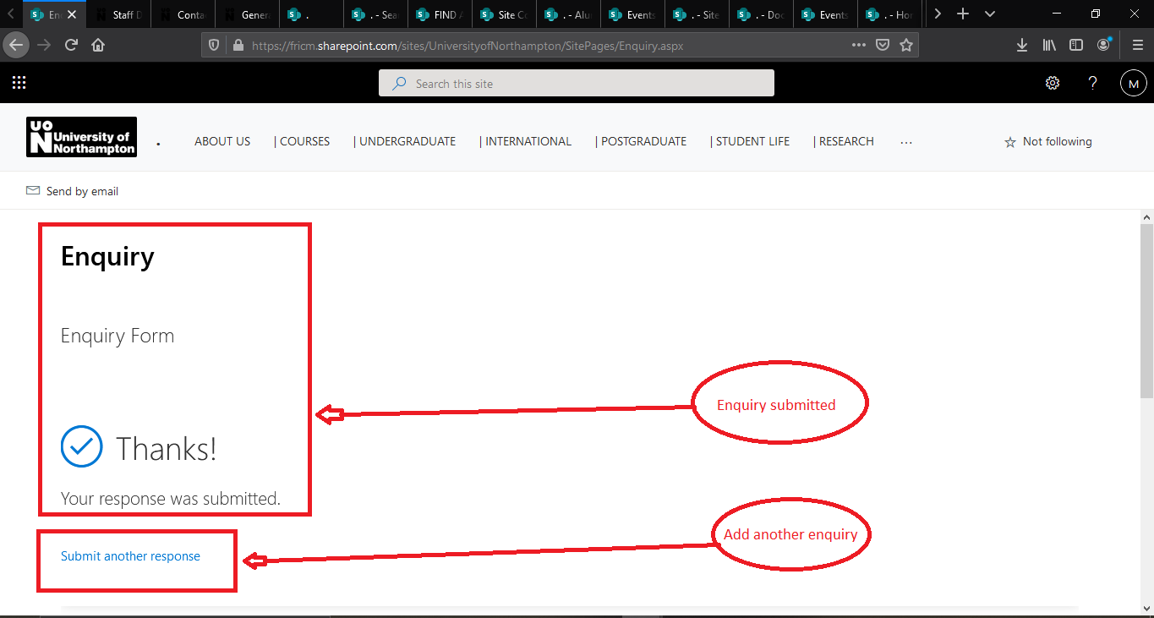

**Figure:**  Successfully submit the form and can submit another enquiry.

|  |  |  |  |  |
| --- | --- | --- | --- | --- |
| Test ID | Name of test | Description | Outcome | Result |
| 3 | Function Testing | Testing the accuracy of functionality of the system has required | According the requirements the Functions has work perfectly | PASSED |

**4. Usability Test**

**Usability Test 1**

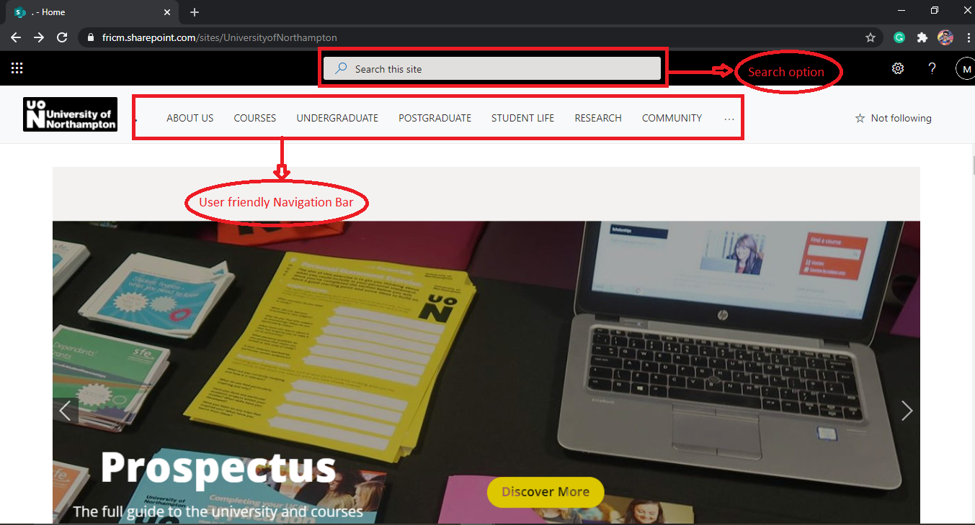

**Figure:**  User-friendly navigation Bar and search option

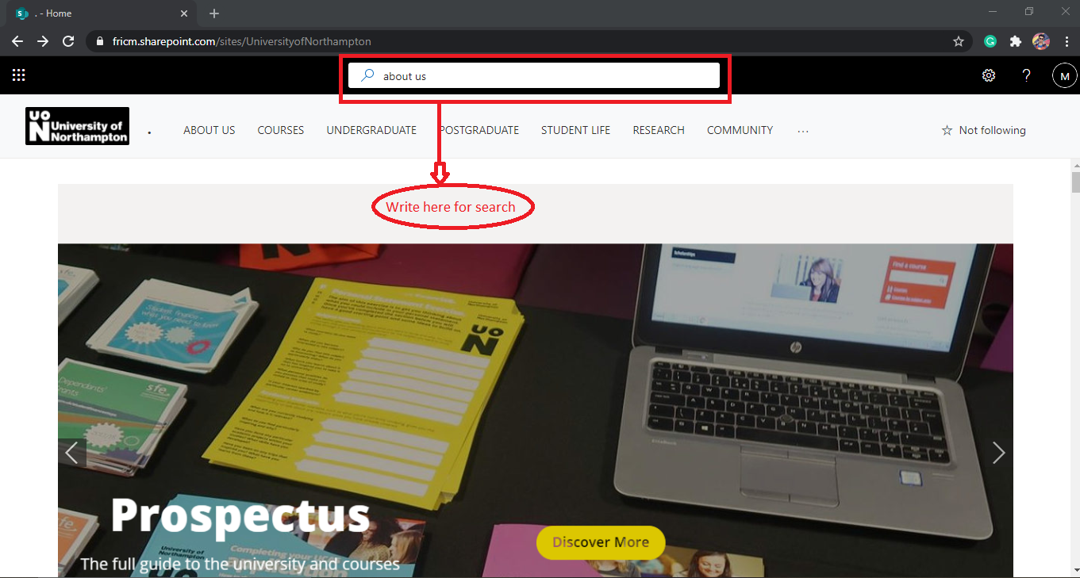

**Figure:**  In search option search about us page.

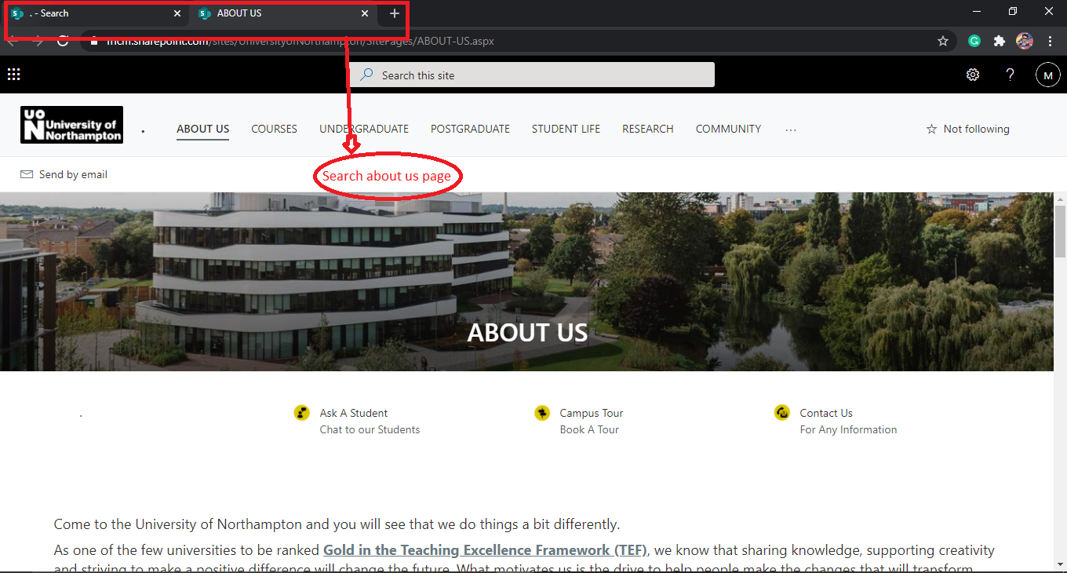

**Figure:**  searching result about us page.

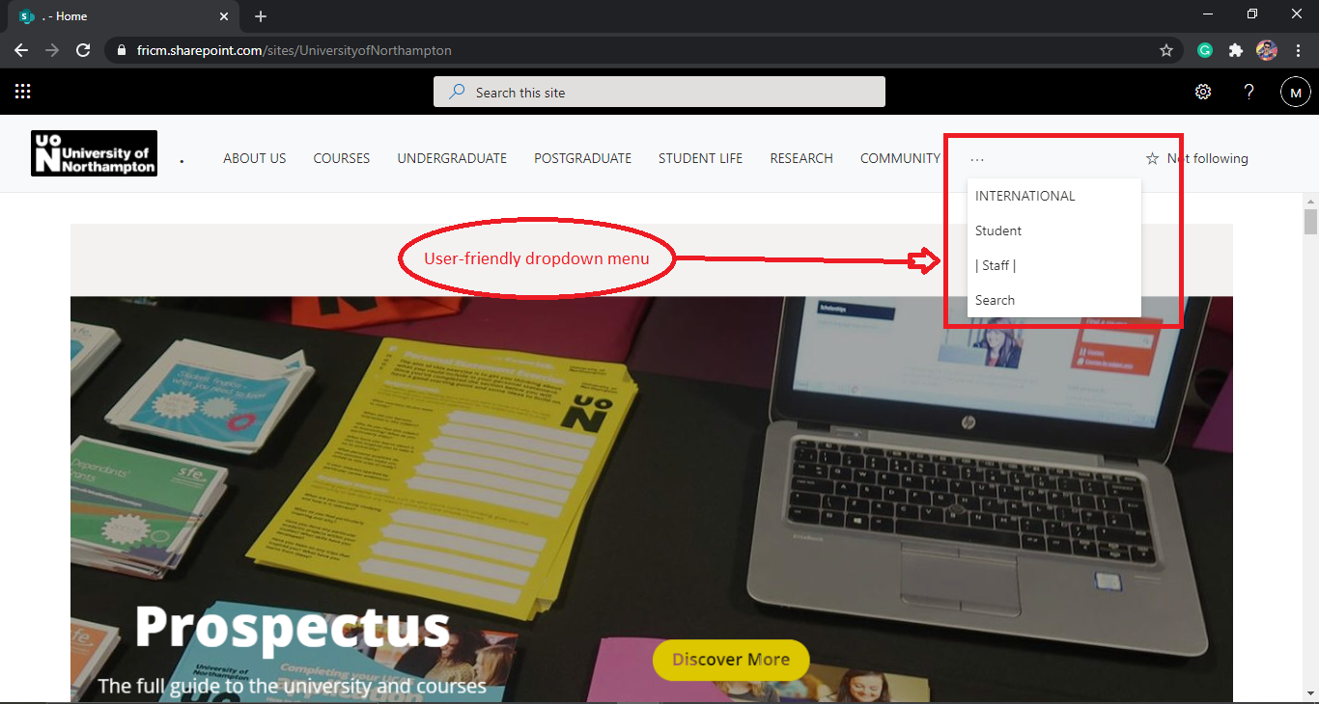

**Figure:**  User-friendly dropdown menu.

|  |  |  |  |  |
| --- | --- | --- | --- | --- |
| Test ID | Name of test | Description | Outcome | Result |
| 4 | Usability test | Testing how easy a user complete a task in the system | The control of the whole system was easy. | PASSED |

**5. Security test**

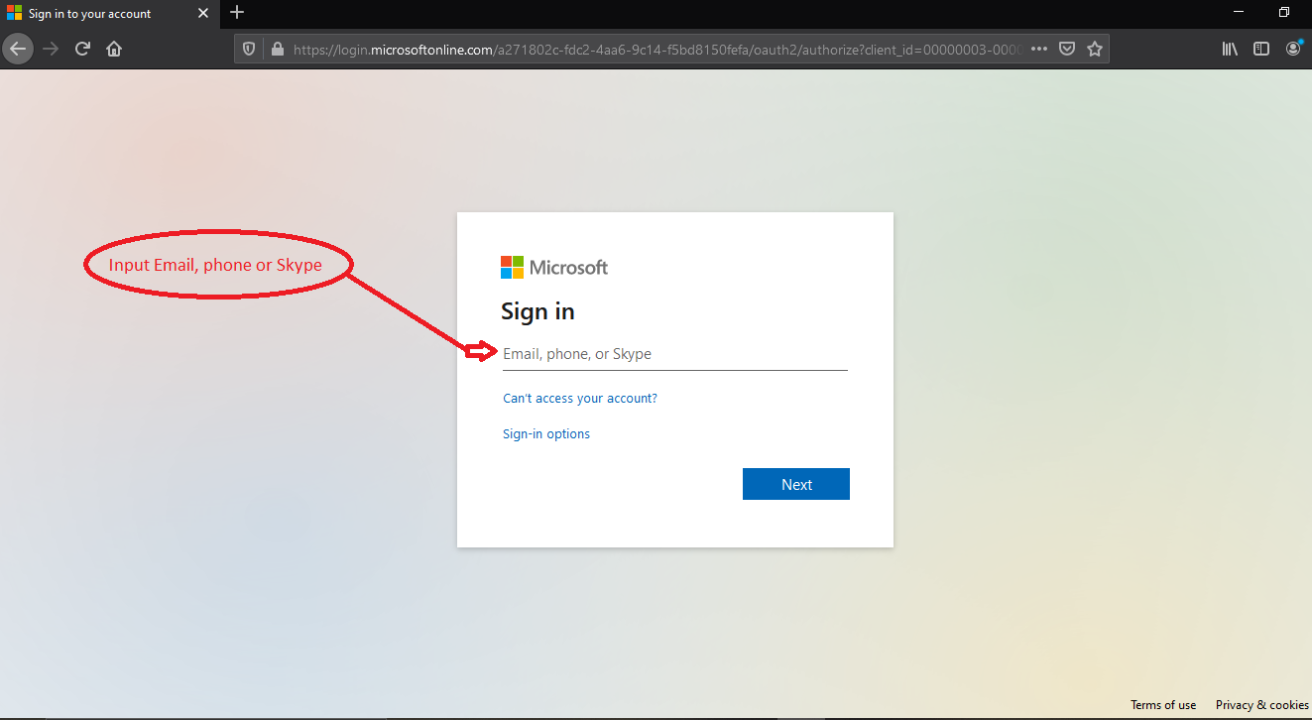

**Figure:** Without genuine email id user will not access the system.

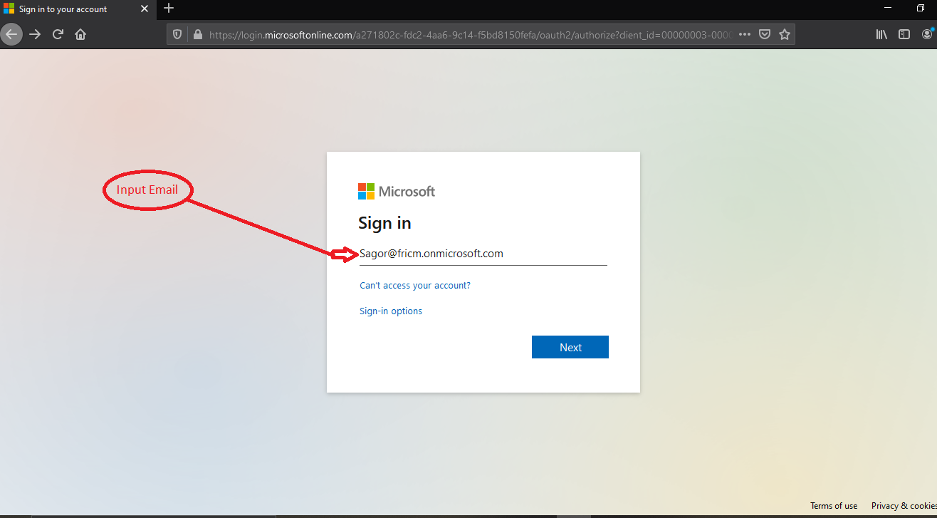

**Figure:** input the genuine email id.

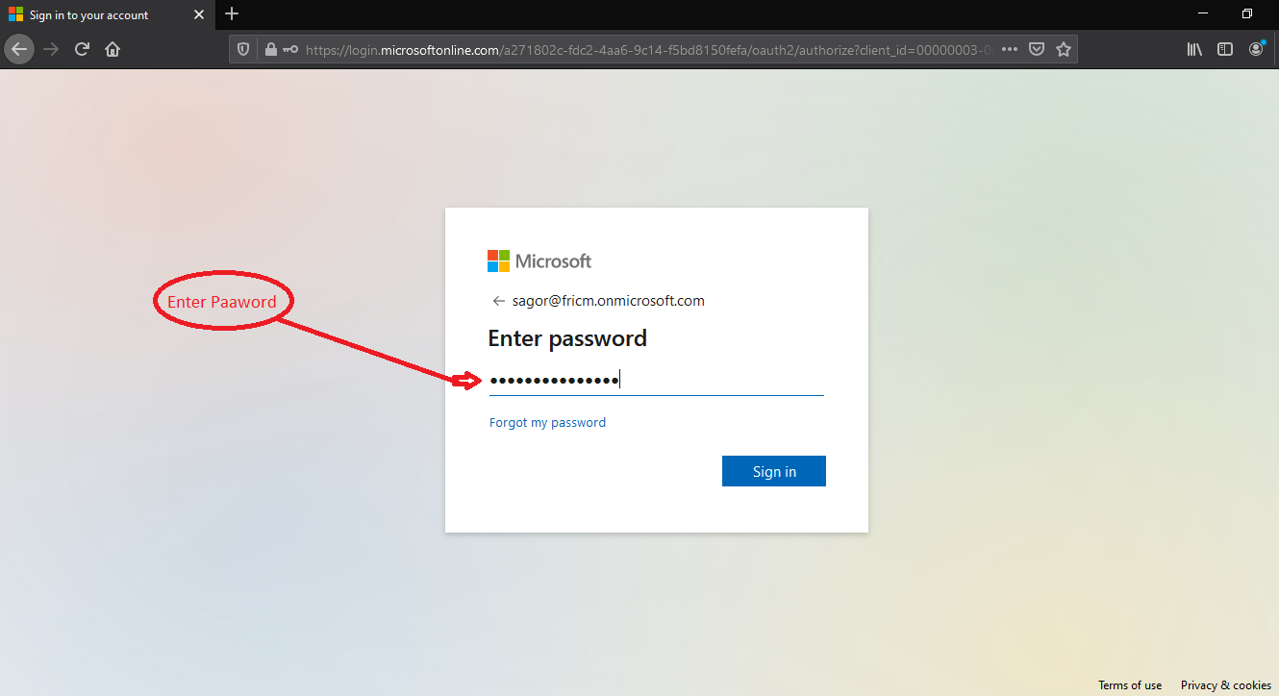

**Figure:** input the genuine password for login.

|  |  |  |  |  |
| --- | --- | --- | --- | --- |
| Test ID | Name of test | Description | Outcome | Result |
| 5 | Security test | Test is there any security threats have in the system. | The whole system security was been well enough |  |

**6. Browser Compatibility Testing**

**Browser Compatibility Testing 1**

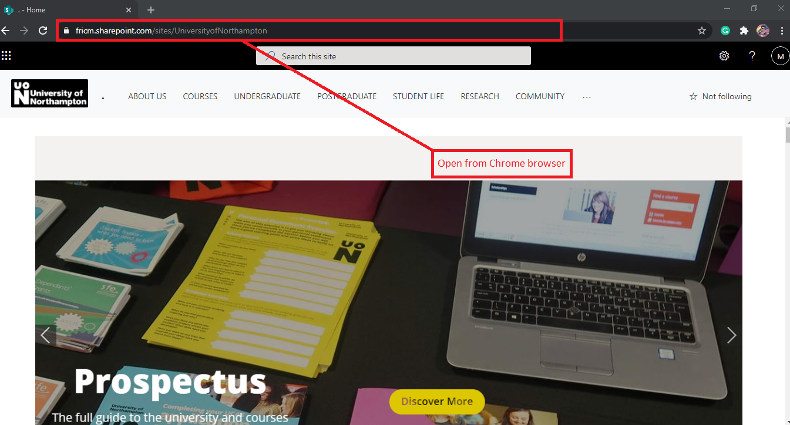

**Figure:** Open from chrome browser

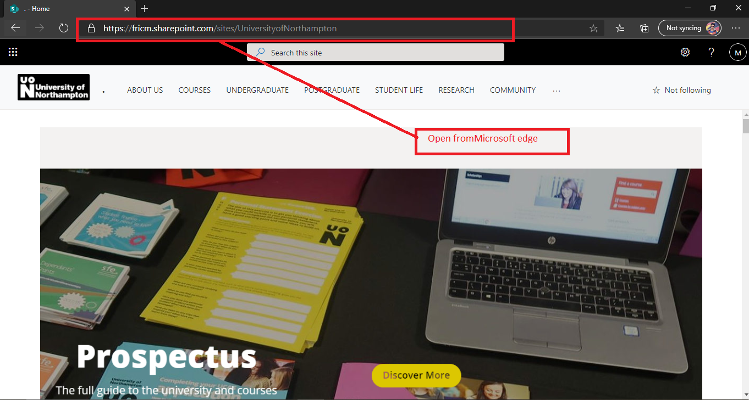

**Figure:** Open from Microsoft edge browser.

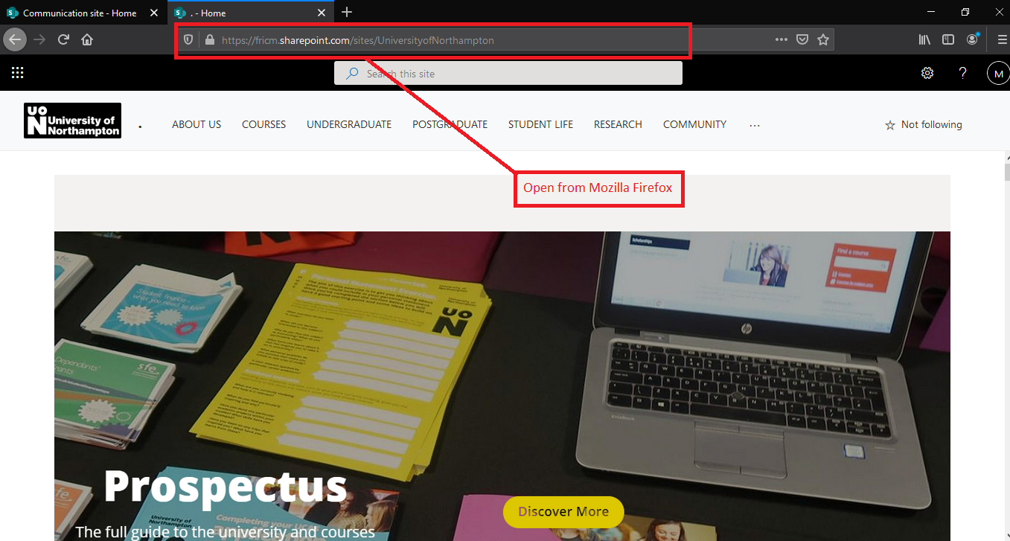

**Figure:** Open from Mozilla Firefox browser.

|  |  |  |  |  |
| --- | --- | --- | --- | --- |
| Test ID | Name of test | Description | Outcome | Result |
| 6 | Browser compatibility test | Running the system in different browser platform | The system was perfectly run in every different browser platform | PASSED |

**7. Responsive Test**

**Responsive Test 1**

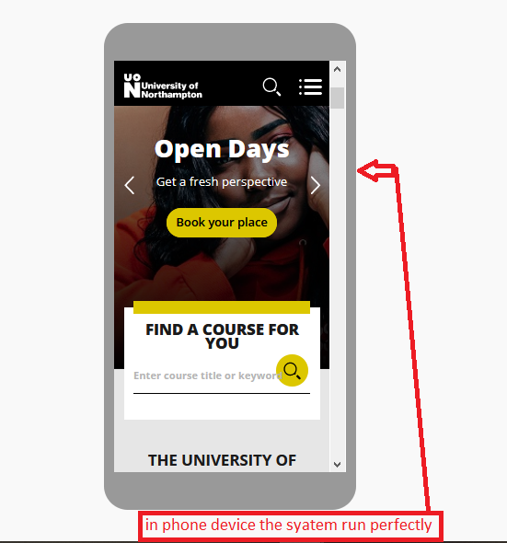

**Figure:** Responsive the system in phone.

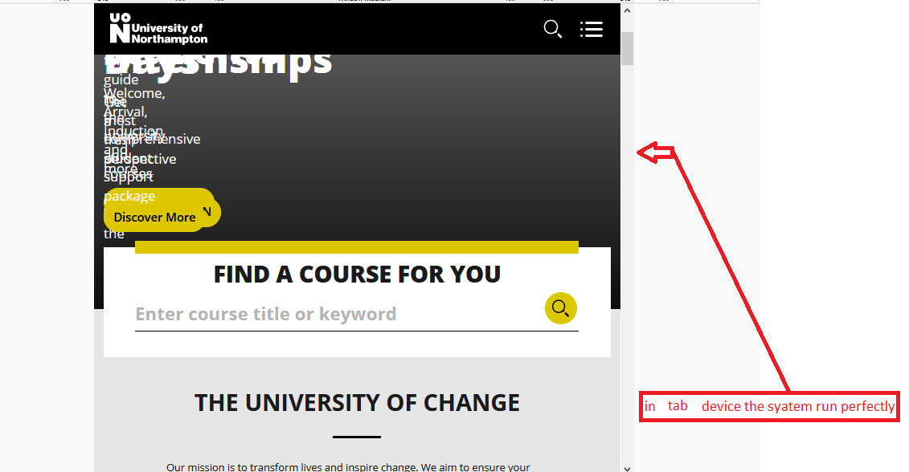

**Figure:** Responsive the system in tab.

|  |  |  |  |  |
| --- | --- | --- | --- | --- |
| Test ID | Name of test | Description | Outcome | Result |
| 7 | Responsive Testing | Test runs the website in different device. | The website should be run perfectly in possible different device. | PASSED |